**Worksheet 2.1: Creating your first JavaScript**

**What will I learn by completing this worksheet?**

* Linking to external JavaScript files and including in the header and body
* Writing your first JavaScript and outputting with HTML tags
* JavaScript variables and concatenation
* For loops in JavaScript

**Task 1 – Setting up the files and folder**

Make a new site in Dreamweaver. For all new sites start the good habit of creating separate folders for **images**, **styles** for CSS style sheets and **js** for the JavaScript. The images folder should be set as the default images folder when you set up the Dreamweaver site.

After making the folders….

1. Create an HTML5 file called script.html
2. Create a JavaScript file called script.js and save it in the js folder

**Task 2 – Linking the files**

In the document called script.html, add the following lines in the head:

<script language=”javascript” type=”text/javascript” src=”js/script.js”></script>

**Task 3 – Write your JavaScript**

In the file called script.js, write the following lines:

document.bgColor ="Red";

Load the XHTML document into your browser, if the background turns red then all is well; if it doesn’t then you will need to check your code to make sure that all documents are linked properly.

**Common error**: Using a space in a file name – don’t do it!

**Task 4 –Another way to include JavaScript**

Within the <body> of the script.html you made in the previous tasks, add <script></script> tags and set the document background colour to blue.

When you load the page in a browser what colour will the background be? Write what it was here: Blue

**Task 5 - Variables**

Let’s try using a website to help us develop JS: <http://jsfiddle.net/>

Your teacher will demonstrate JavaScript variables and how to concatenate two strings. Then using the JavaScript we have worked with already, write a script to store your forename and surname in variables with appropriate names; then output them both as a full name to the browser window.

Paste your code and a sensibly cropped screen grab of it running here:

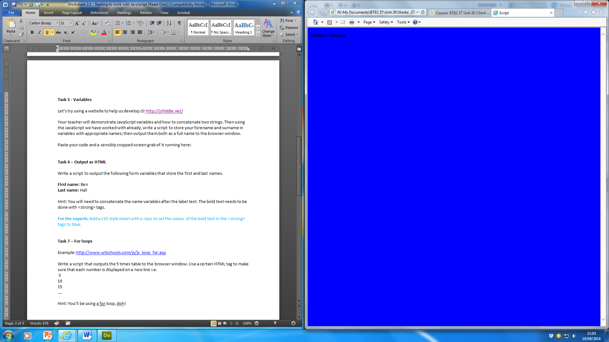

<body>

<script>

{

var firstname = "Matthew";

var lastname = " Hawkins";

var fullname = firstname + lastname;

document.write(fullname);

document.bgColor="Blue";

}

</script>

</body>

**Task 6 – Output as HTML**

Write a script to output the following form variables that store the first and last names.

**First name:** Ben  
**Last name:** Hall

Hint: You will need to concatenate the name variables after the label text. The bold text needs to be done with <strong> tags.

**For the experts**: Add a CSS style sheet with a class to set the colour of the bold text in the <strong> tags to blue.

**Task 7** **– For loops**

Example: <http://www.w3schools.com/js/js_loop_for.asp>

Write a script that outputs the 5 times table to the browser window. Use a certain HTML tag to make sure that each number is displayed on a new line i.e.

5

10

15

….

Hint: You’ll be using a for loop, doh!

**Task 8 for the experts (Arrays)**

You probably worked with some arrays briefly during your work with VB.NET if you did stretch work. We use them to store an ordered group of data values to save declaring lots of similar variables.

We declare with square brackets and each element has a unique index number starting from 0.

var car = [];

car[0] = "Blue";

car[1] = "Red";

Another approach is to populate element at declaration:

var car = [“Blue”,”Red”]

Which achieves the same result as the 2 lines above it.

Paste this in to jsfiddle.net and add the following line:

alert(car[1]);

1. What did it output when you ran it? Paste a screen grab here:

Another useful property to know is .length. Add the following line:

alert(“Length of array is “ + car.length)

2. What did it output? Paste a screen grab here:

3. How could you use .length to find the index of the last element in an array? Paste the code you used here:

4. Write a script with an array of 4 student names, which uses a for loop to output the array to the browser window. Look up how to do a ***for…in*** loop for a more efficient loop through the arrays – you should find this on page 70 of the textbook.